## MICROPROCESSOR BASED SYSTEM DESIGN LAB

**Lab #01**



## Spring 2022 CSE307L MBSD Lab

Submitted by: **Ashfaq Ahmad** Registration No.: **19pwcse1795** Class Section: **B**

Student Signature:

Submitted to:

## Prof : Aber Irfan sab

August 1, 2022

# Department of Computer Systems Engineering University of Engineering and Technology, Peshawar

**Task:**

Write a detailed lab report on Introduction to 8051 Microcontroller & Installation of Software (Proteus and Keil).

# Objectives of the lab

* To get familiar with Keil μVision Integrated Development Environment(IDE).
* Familiarization with 8051 Microcontroller.
* Designing an 8051 Starter Kit
* Toggling I/O Port.

# Hardware & software requirement

* Breadboard
* 8051 Microcontroller (AT89C51)
* Crystal Oscillator, Capacitors, Resistors and LEDs
* 8051 Assembler (Keil μVision).
* 8051 Programmer.

**Starter Circuit**

* AT89C51 have 40 pins dedicated for various functions such as I/O, -RD, -WR, address, data, and interrupts.
* The 8051 has an on-chip oscillator but requires an external clock to run it. A quartz crystal oscillator is connected to inputs XTAL1 (pin19) and XTAL2 (pin18). The quartz crystal oscillator also needs two capacitors of 30 pF value

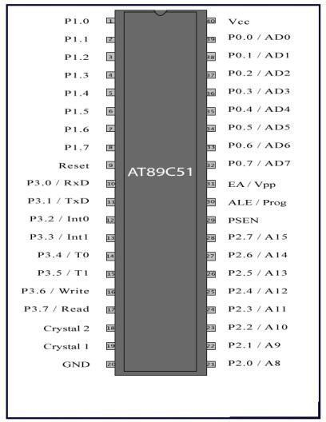

# Proteus Professional Introduction

1. Open proteus from the Start menu
2. The Figure below shows the basic windows referred in this document.

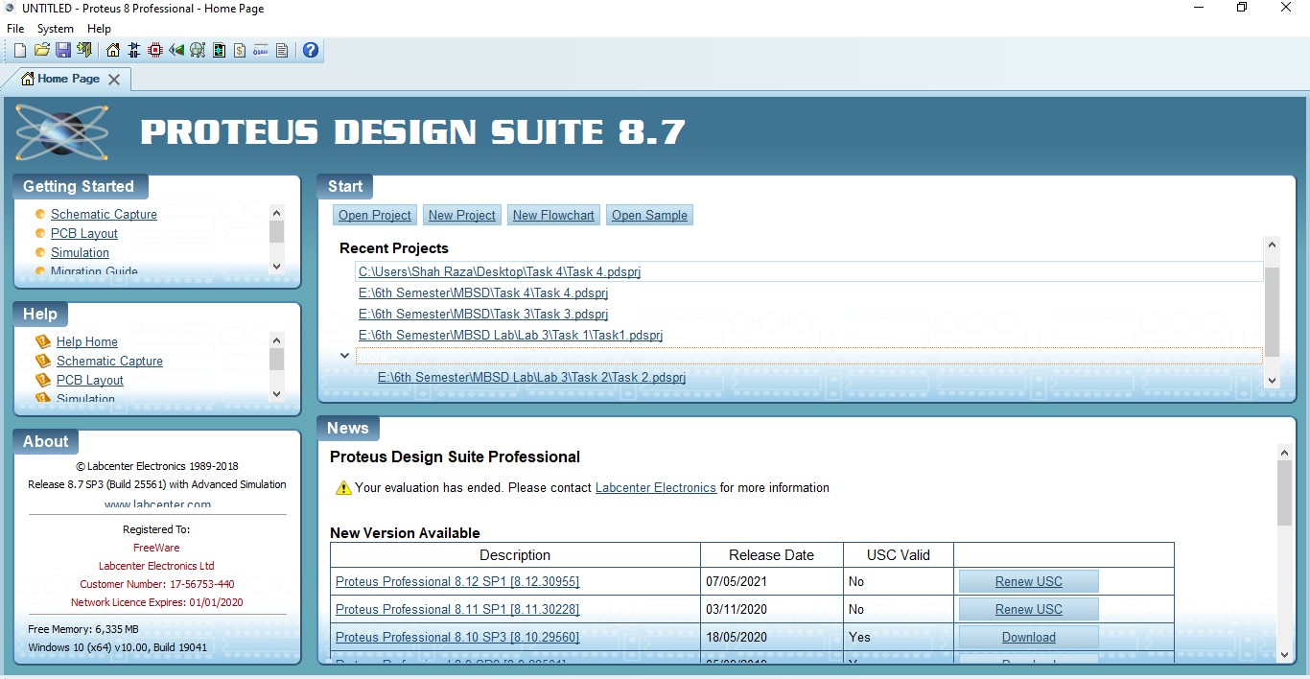

# Starting a New Project

1. Select New Project from the Start Menu.
2. Name the project *Toggle*
3. Click on the Next Button

The device window will be displayed.

1. Select the part you will be using to test with. For now, we will use the 80C51.

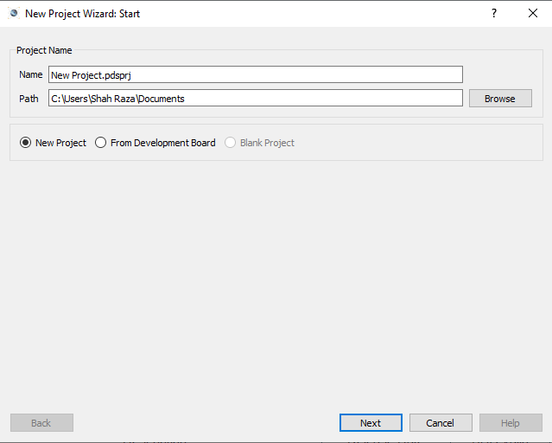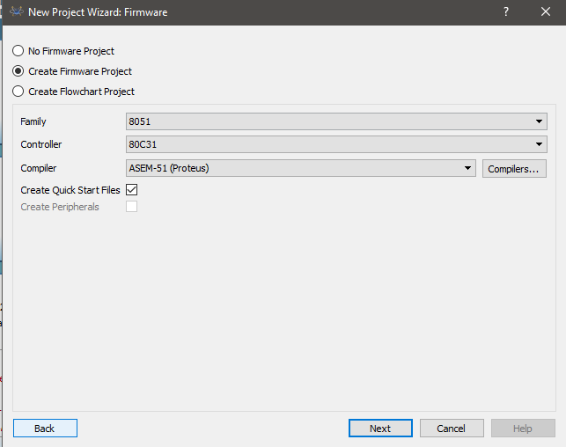

# Creating Source File

1. It opens automatically a source file for you according to the selected the compiler.
2. It’s a .asm file or .c for using c language.

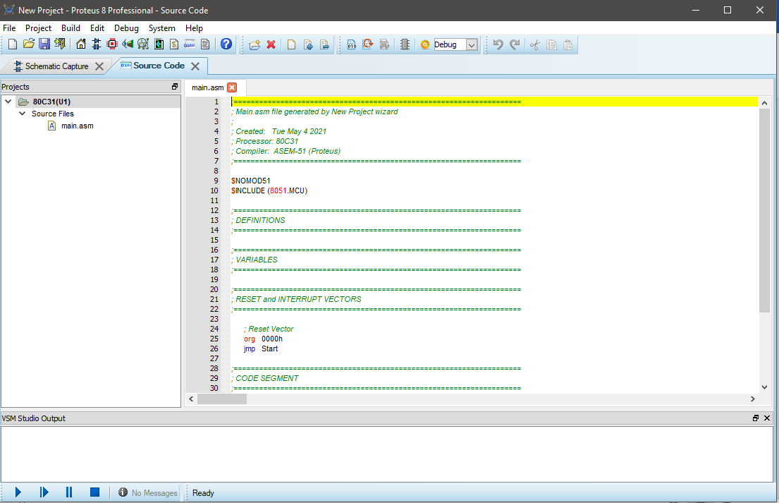

# Testing Program in Debugger

1. Click on the Project menu and select Build all Target Files.
2. In the build window it should report ‘0 Error(s) and 0 Warnings’ 11.Click on Debug menu and select ‘Start/Stop Debug Session’.
3. To exit out, click on Debug menu and select ‘Start/Stop Debug Session’.
4. 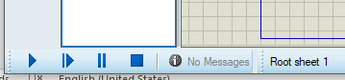At the End of the window compiling options.

# Keil uvision5 Introduction Starting a New Project

1. Select New Project from the Project Menu.
2. Name the project *Toggle*
3. Click on the Save Button

The device window will be displayed.

1. Select the part you will be using to test with. For now, we will use the Atmel’s AT89C51

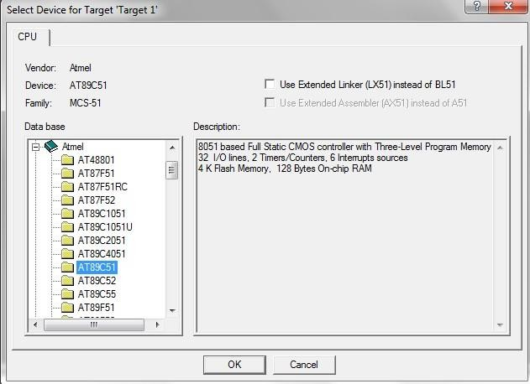

# Creating Source File

1. Click File Menu and select New.
2. A new window will open up in the KeilIDE.
3. Copy the code given below in assembly language in the new window. This code will toggle Port 1 and Port 2 continuously.
4. Click on the file menu and select Save.
5. Name the file Toggle.asm

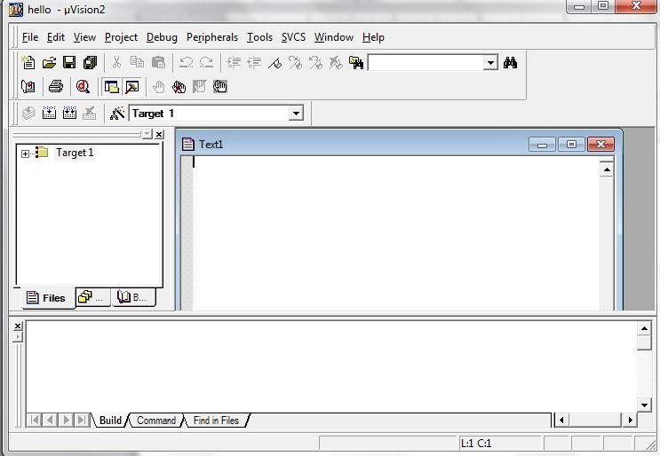

# Adding File to the Project

1. Expend Target1 in the tree menu.
2. Click on Source Group1 and select Add file to Group ‘Source Group1’.
3. Change file type to Asm Source File (*.a, *.src, *.asm).
4. Click on Toggle.asm and select Add button.
5. Click Close button.
6. Expend the Source Group 1 to ensure that the file was added.

# Creating HEX file

1. Select on Target 1 in tree menu.
2. Click on Project menu and select Options for Target 1.
3. Select Output tab and then select Create Hex File check box.
4. Click Ok button.

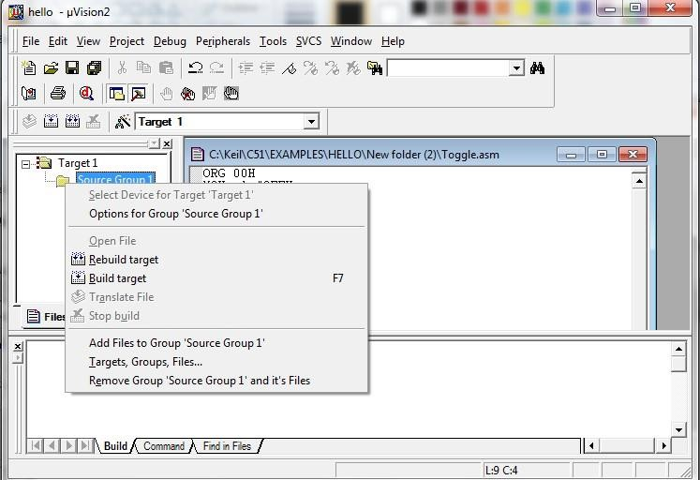

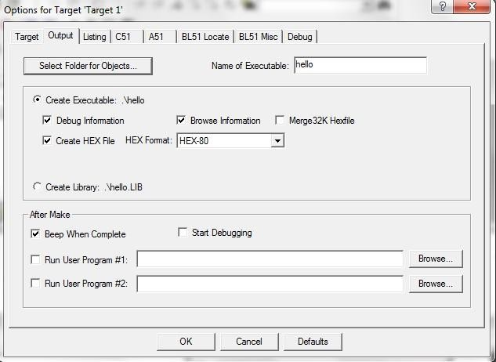

# Testing Program in Debugger

1. Click on the Project menu and select Build all Target Files.
2. In the build window it should report ‘0 Error(s) and 0 Warnings’
3. Click on Debug menu and select ‘Start/Stop Debug Session’.
4. Click on Peripherals and select I/O Ports.
5. Select Port 1 and Port 2.
6. Step through the code by pressing F11 on the keyboard. The Port Boxes change with passing instructions.
7. To exit out, click on Debug menu and select ‘Start/Stop Debug Session’.

